
Work Instruction for Firmware Upgrade of Cisco Blade Servers

Viatris
Work Instruction for Firmware Upgrade of Cisco Blade Servers

Contents
Contents 2
1. Introduction 3
1.1. Purpose 3
1.2. Scope of this Report 3
1.3. Audience 3
2. Approach and Methodology 3
2.1. Approach 3
2.2. Methodology 3
3. Technical Details 3
3.1. Step 1 3
3.2. Step 2 5
3.3. Step 3 7
4. Roles and Responsibilities 9
5. Escalation Matrix 9
6. Related Documentation 9
6.1. Additional Documentation 9
7. Version Control 10

1. Introduction

1.1. Purpose
This document will provide the procedure to be followed for firmware upgradation of Cisco Blade Servers.

1.2. Scope of this Report
The purpose of this guide is to provide details on how cisco blade servers are upgraded in firmware.

1.3. Audience
GIDC Unix Group

2. Approach and Methodology

2.1. Approach

2.2. Methodology
    - Step 1: - In the server take the necessary pre-evidence click as well as select the required fields, plus take the boot LUN, and boot order details screenshot.
    - Step 2: -In the boot policy take the evidence shut down server once the required evidence is captured, plus click and select the necessary fields which results in upgradation of firmware version.
    - Step 3: -After that make the necessary changes monitor the upgrade status check the same, power on the server and validate the server functionality.

3. Technical Details

3.1. Step 1
3.1.1. Go to the server and take the pre-evidence for LUN boot order & boot policy details.
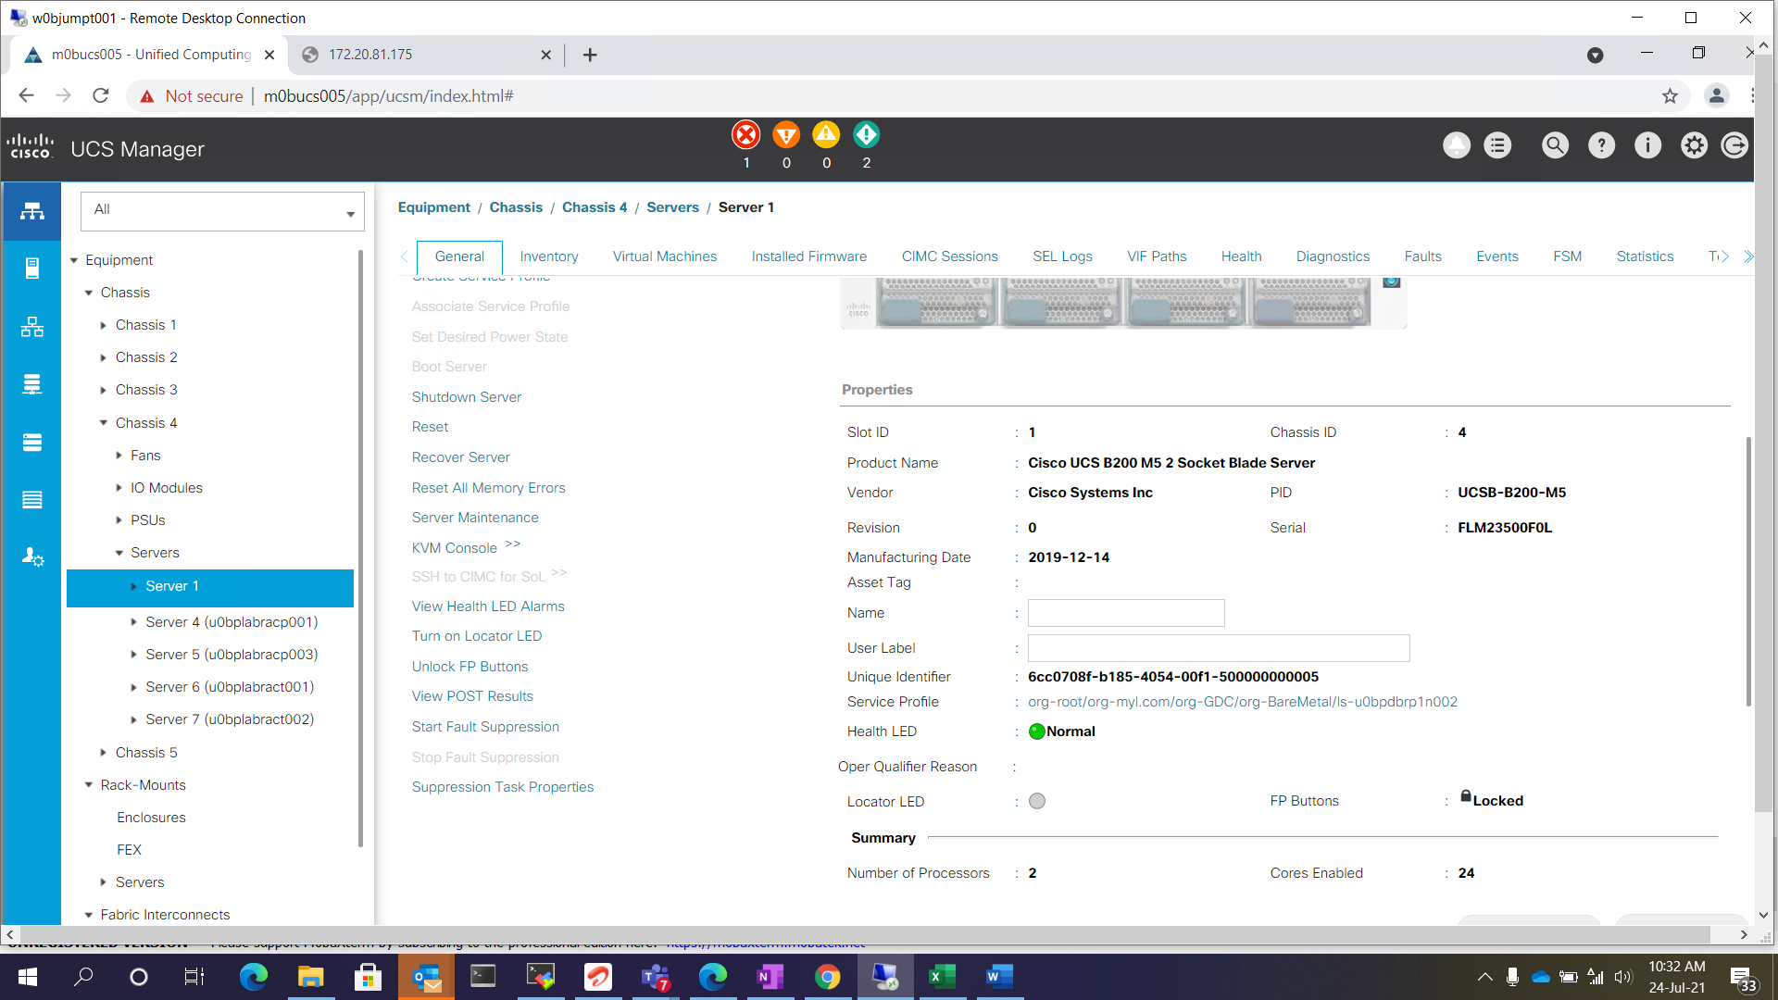
    - Click the service profile and select the boot order.

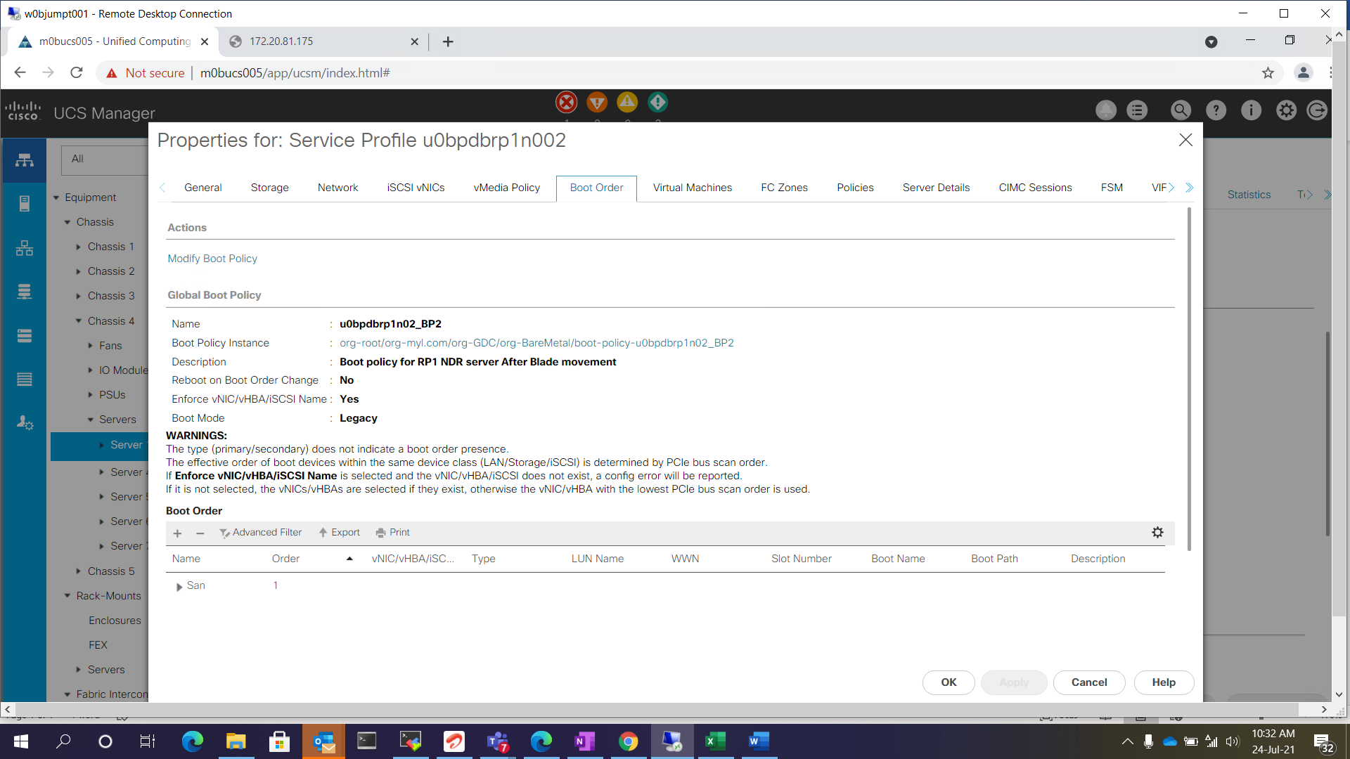
    - Take the boot LUN and boot order details screen shots

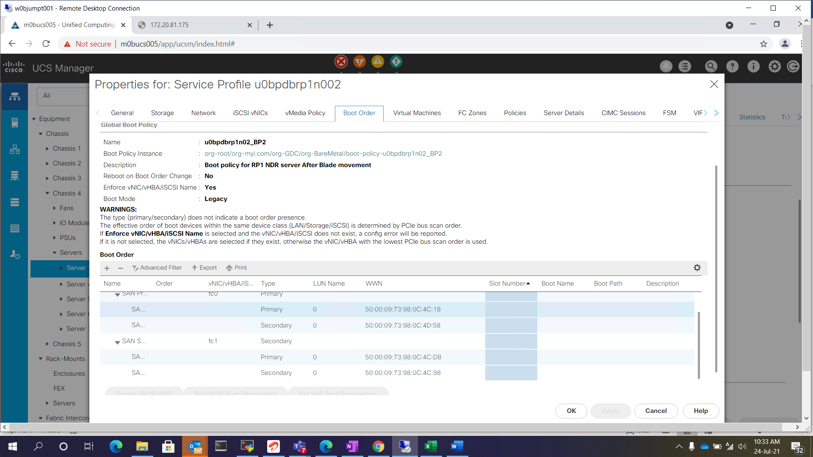

Step 2
    - Click the boot policy and take the evidence.

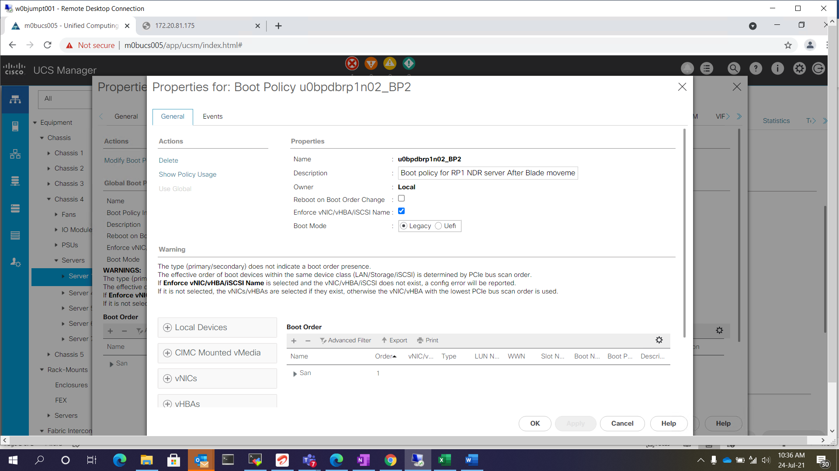

    - Once pre-evidence are captured and shutdown the server.

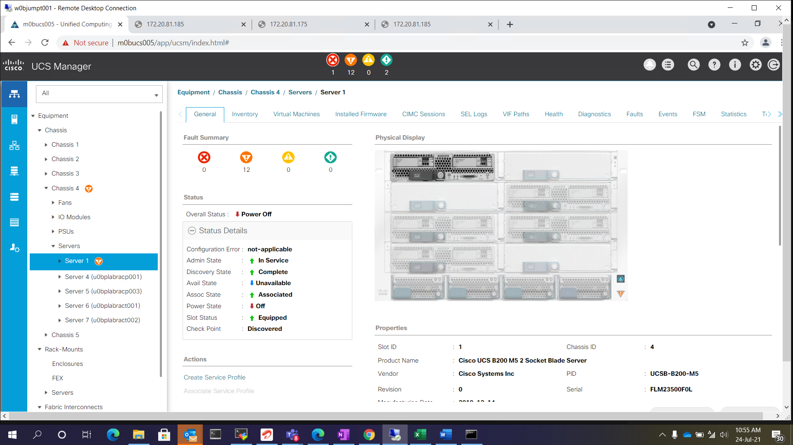

    - Click the service profile and go to the policies tab and select the firmware version, which need to be upgraded.
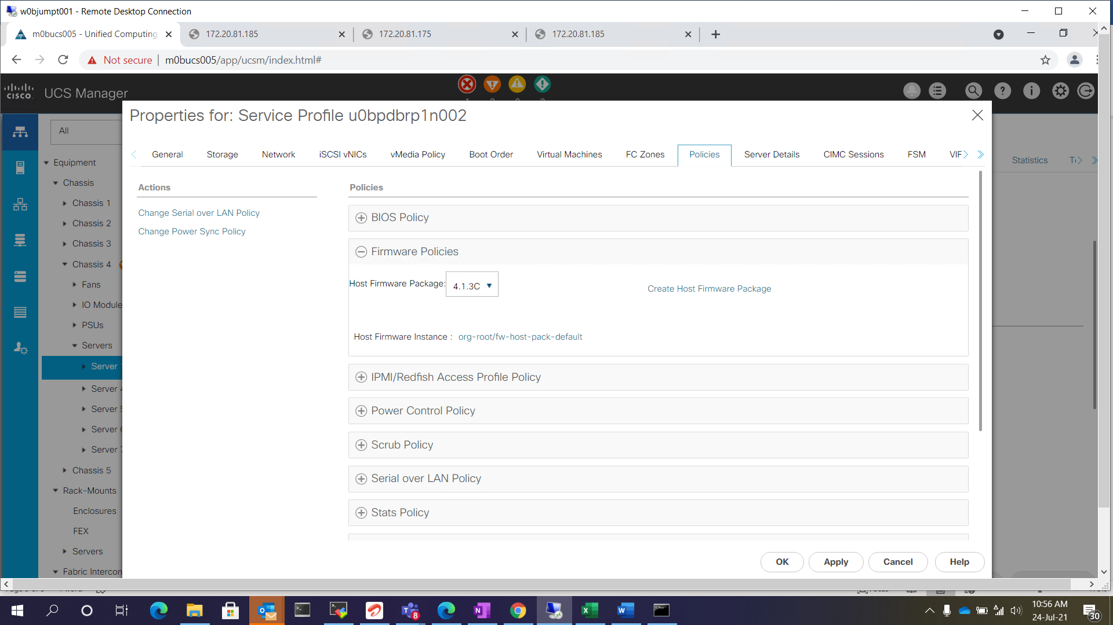

Step 3
    - Apply and save the changes and firmware will be upgrade automatically.

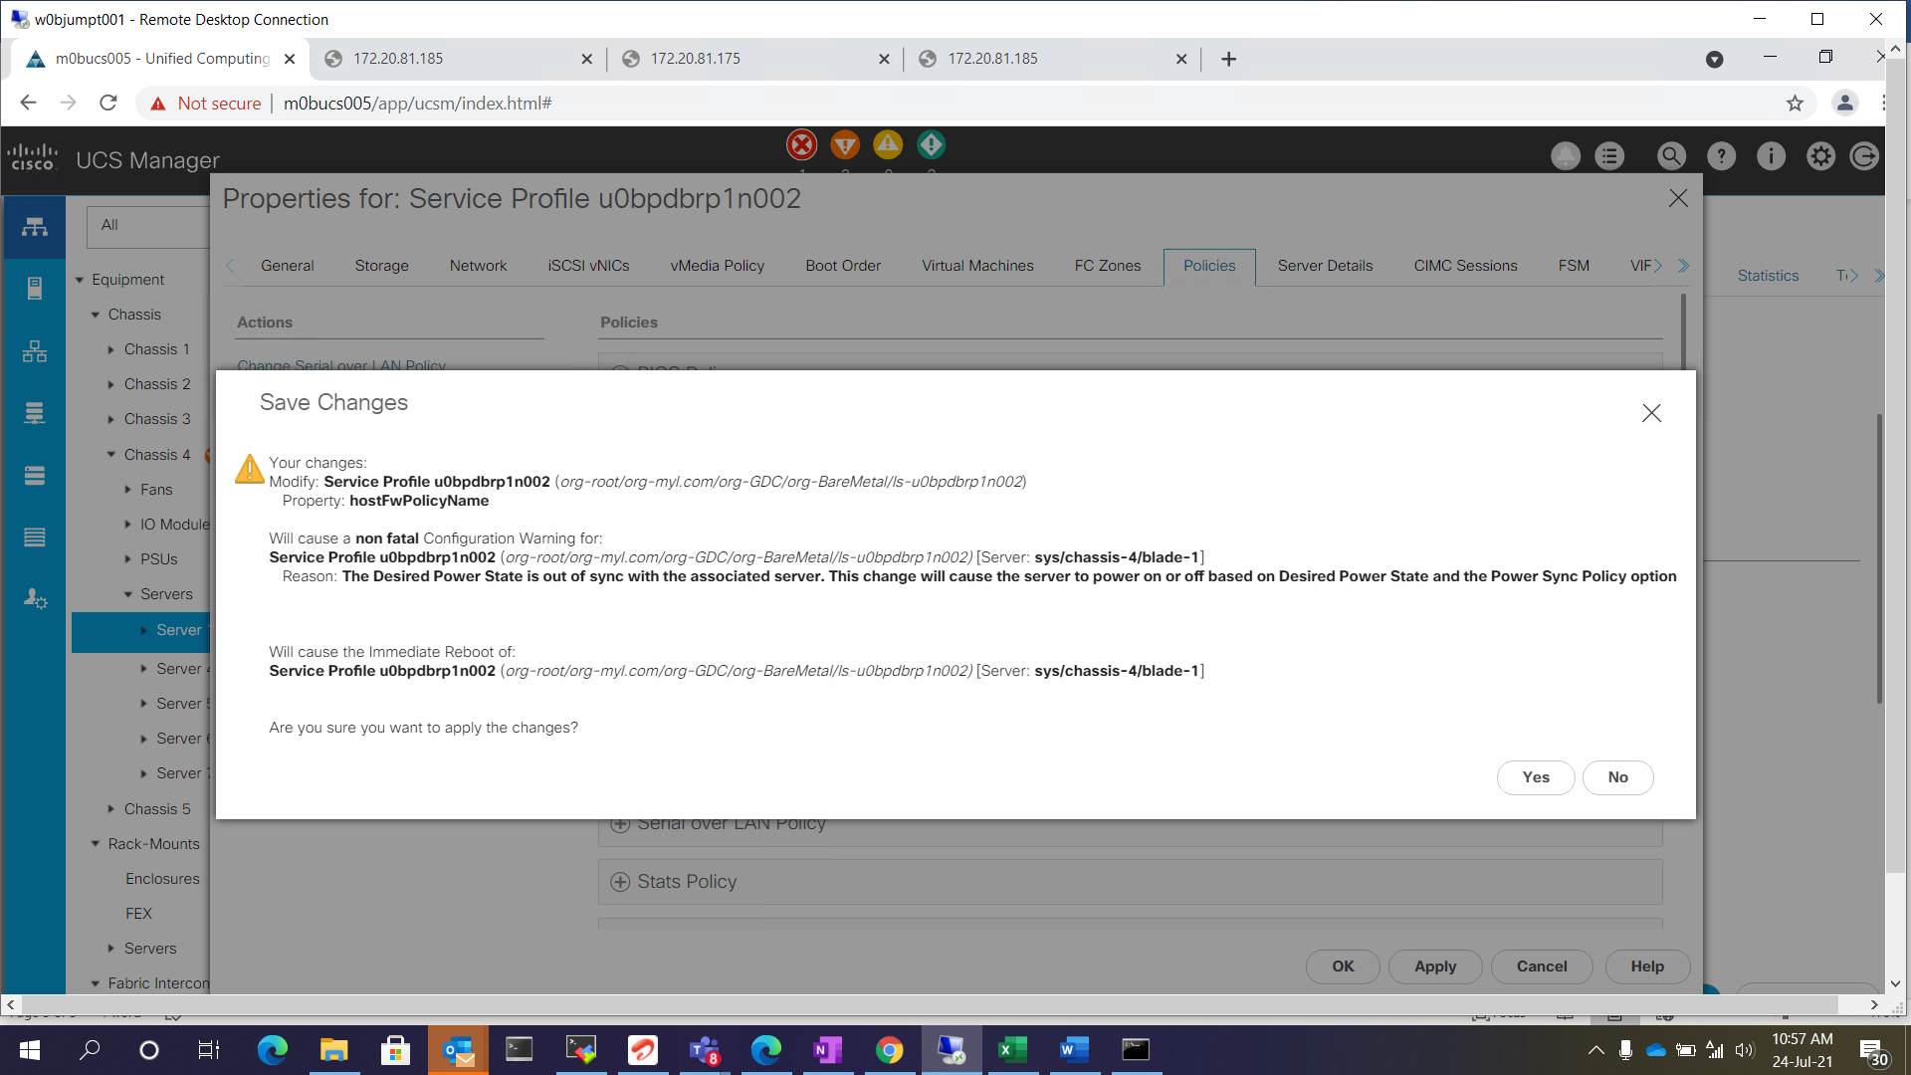

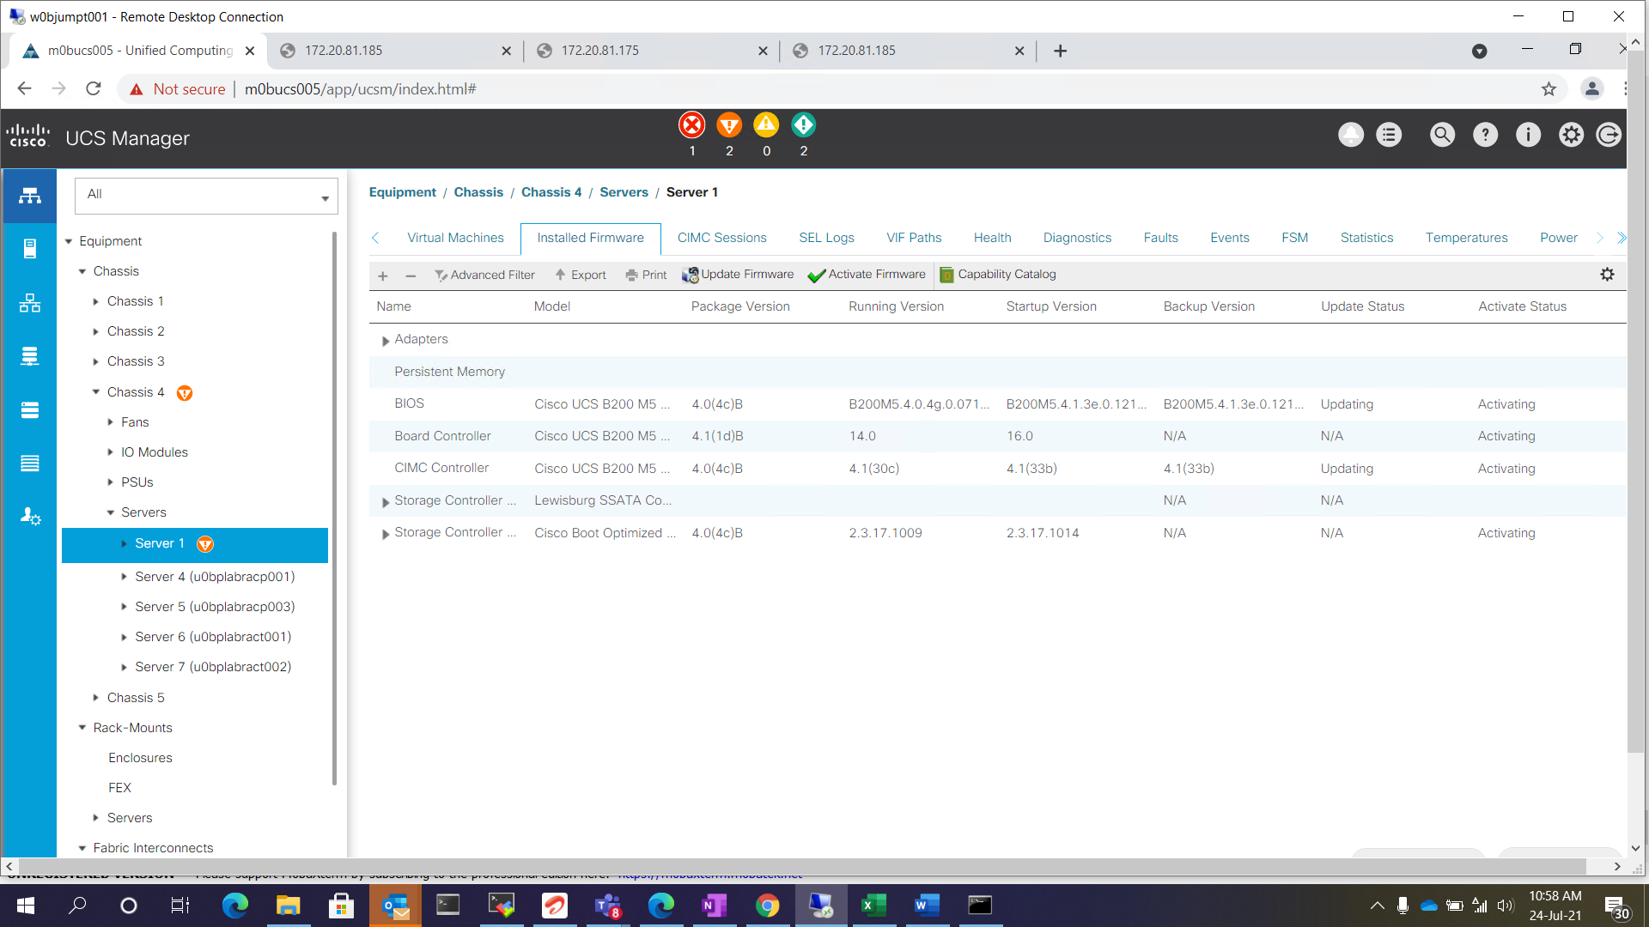
    - Go to the FSM Tab and monitor the firmware upgrade status.
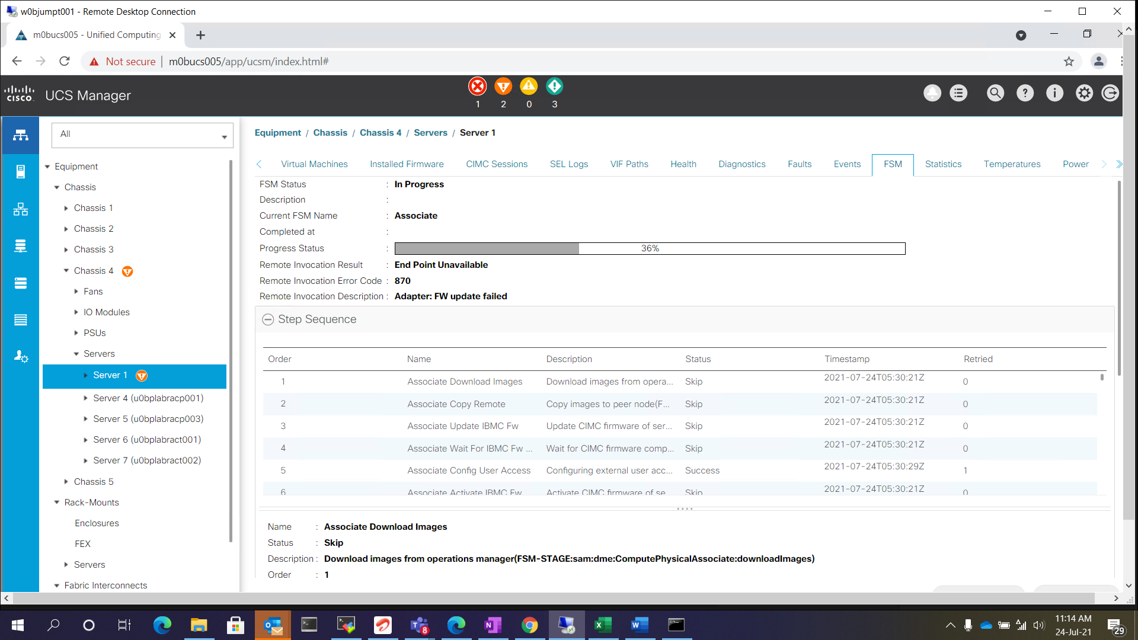

    - Once firmware is done check the firmware updated. And power on the servers and validate the server functionality.
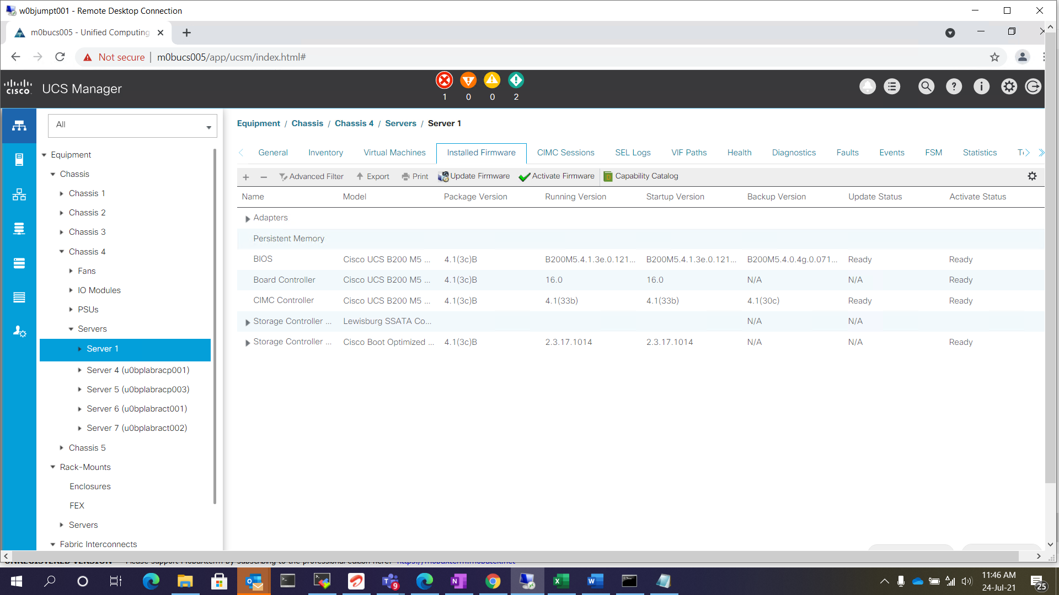

Roles and Responsibilities
Sl. No. | Roles | Responsibilities | Team Member Name
1. | Maintenance Window | Respective Team / Unix Team | GIDC.unix_Run  GIDC.unix_Run@viatris.com
2. | Change Request | Respective Team / Unix Team | GIDC.unix_Run  GIDC.unix_Run@viatris.com
3. | Change Implementation | Respective Team / Unix Team | GIDC.unix_Run  GIDC.unix_Run@viatris.com
4. | Hyper Care | Respective Team / Unix Team | GIDC.unix_Run  GIDC.unix_Run@viatris.com

5. Escalation Matrix
Person Responsible | Role | Triggers When
Arun R  Arun.R@viatris.com  +91 9710677240 | SME
Ashok Kumar R K  AshokKumar.RK@viatris.com  +91 9967735890 | Manager
Mohandoss Murugesan  Mohandoss.Murugesan@viatris.com  +91 6366966170 | Senior Manager

6. Related Documentation

6.1. Additional Documentation

7. Version Control
Date | Version | Summary of Changes | Author | Approved by
May 19 2021 | V1.0 | Updated Organization Detail | Franklin Kabila Dhas | Arunachalam G
Apr 5 2023 | V1.1 | Updated in New Template | Ashok Kumar RK | Mohandoss Murugesan
Dec 28 2024 | V1.2 | Validated the Document | Benesh Selva Nesan P | Arun R

